**Project Design Phase-II**

**Data Flow Diagram & User Stories**

|  |  |
| --- | --- |
| **Date** | 21 October 2022 |
| **Team ID** | **PNT2022TMID47589** |
| **Project Name** | Personal Assistance for Seniors who are Self-Reliant |
| **Maximum Marks** | 4 Marks |

**Data Flow Diagram:**

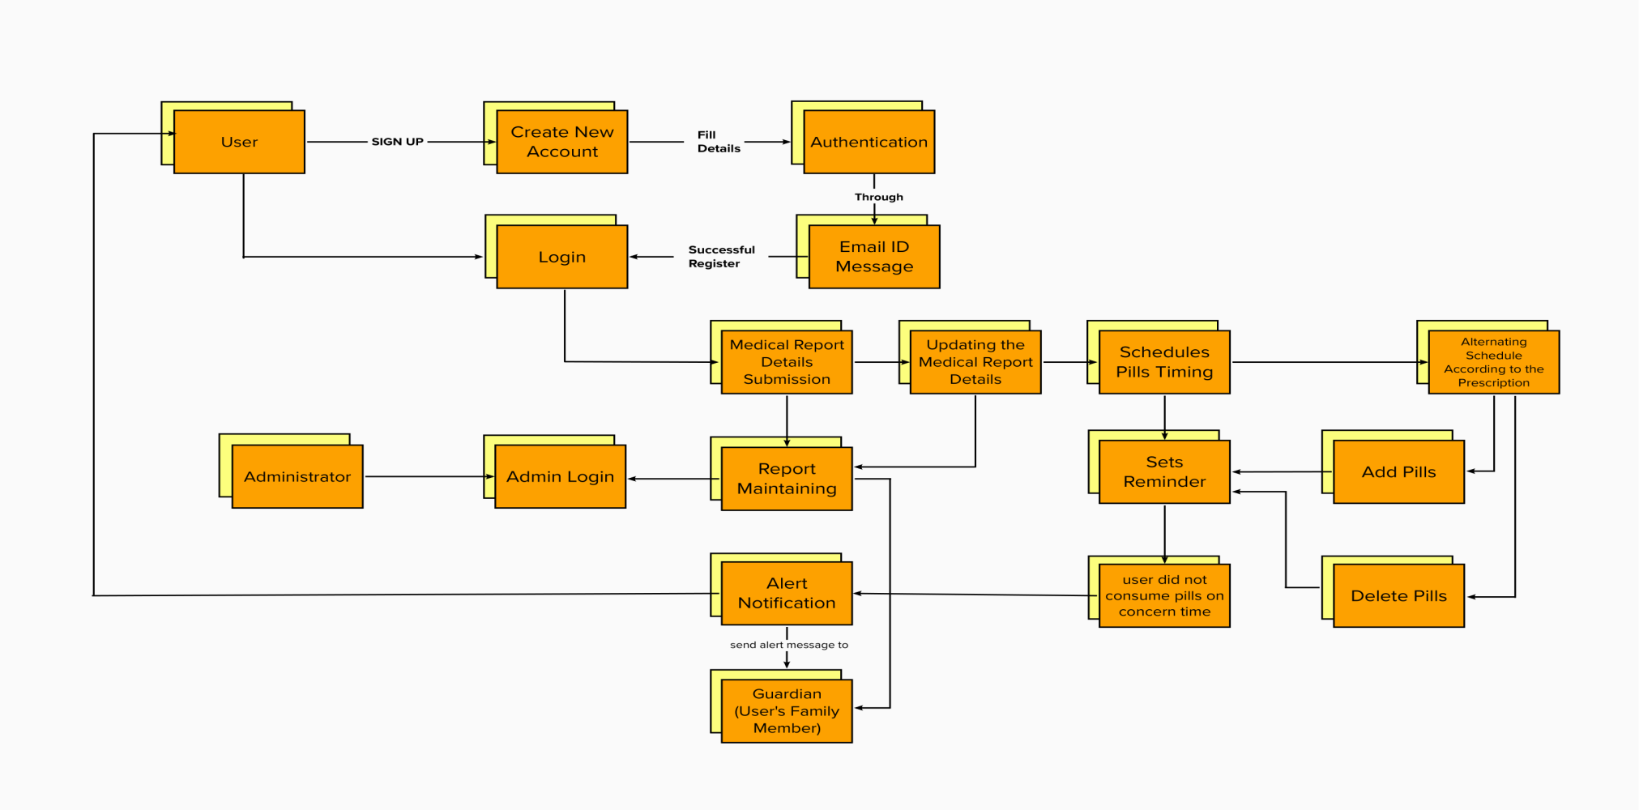

**USER STORIES:**

Use the below template to list all the user stories for the product.

| **USER TYPE** | **FUNCTIONAL REQUIREMENT (EPIC)** | **USER STORY NUMBER** | **USER STORY / TASK** | **ACCEPTANCE CRITERIA** | **PRIORITY** | **RELEASE** |
| --- | --- | --- | --- | --- | --- | --- |
| Customer (Mobile user) | Registration | USN - 1 | As a user, I can register for the application by entering my email, password, and confirming my password. | I can access my account / dashboard | High | Sprint-1 |
|  |  | USN - 2 | As a user, I will receive confirmation email once I have registered for the application | I can receive confirmation email & click confirm | High | Sprint-1 |
|  | Login | USN - 3 | As a user, I can login to the application through the email and phone number | I can register & access the dashboard with Email and phone number Login | High | Sprint-1 |
|  | Medical Report submission | USN - 4 | As a user, Users should produce the Medical Report through the mobile application | Medical Reports are useful for some emergency cases or purpose. | Medium | Sprint-2 |
|  | Updating the Medical Report | USN - 5 | As a user, Can updating their medical report details into the application | Updated medical reports are used to remind the updated pills or Medicine for the Reminder App. | Medium | Sprint-2 |
|  | Schedules Pills Timing | USN - 6 | As a user, I can schedules the pills or Medicine according to the doctor prescribed timings. | I can also modify my medicine schedule in future. | High | Sprit-2 |
|  | Sets Reminder | USN - 7 | As a user, I can set the Pills Reminder through TTS Service | I can Set Reminder | High | Sprit-3 |
| Administrator | Admin Login | ASN - 1 | As a admin, I can Login with the ID and Password. | I Can Check the User Status. | High | Sprit-4 |
|  | Report Maintaining | ASN - 2 | As a admin I Maintain the Report of the user. | Reports are send to the user’s guardian. | Medium | Sprit-4 |
| Guardian | Alert notification | GSN - 1 | As a guardian, they receive alert message when user doesn’t consume their medicine. | An alert message is send to the user and guardian when the user did not consume the concern pills. | Low | Sprit-3 |
|  | Report | GSN - 2 | As a guardian, they get Weekly report and monthly report of the user from the admin | They can learn the health details of the User/patient with the help of the admin | Low | Sprit-3 |